# Staff Report

Meeting Date: September 3, 2024

To: Siskiyou County Board of Supervisors

From: Bernadette Cizin, Associate Planner

Subject: Proposed Barnes / Johnson Agricultural Preserve Amendment, Williamson Act Rescission with Re-entry, Agricultural Preserve Amendment (APA-24-04) and CEQA Determination

## Background and Discussion

On February 27, 2024, the County received an application to adjust the boundary between three separate parcels and a Williamson Act Contract/Agricultural Preserve Amendment application to amend the contracts and preserves to reflect the resultant boundaries.

During the initial review it was found that if the subject property was rescinded from the existing contracts the remaining property would not meet current requirements. Additionally, it was found that two parcels owned by Johnson are substandard in size. The owners were notified and have amended their application to include additional property to be included in the new contracts to ensure that the contracts affected by this project are compliant. Mr. Johnson is aware that it is this departments practice to recommend substandard parcels for issuance of a Notice of Non-Renewal. He has advised staff to move forward with the project as proposed, which includes two substandard parcels under his ownership.

This project does not propose to increase or decrease the acreage of the existing agricultural preserve or contracts. However, because there are substandard parcels that are part of the proposed resultant contract, the county should issue a Notice of Non-Renewal for these parcels as they remain under the 40-acre minimum parcel size requirement.

**Agricultural Preserve Administrator Review**  
Staff prepared a detailed report (Exhibit D) for review and recommendation by the Agricultural Preserve Administrator. Based on the report, the Administrator found the applicant’s request is consistent with the County Rules for the Establishment and Administration of Agricultural Preserves and Williamson Act Contracts and recommends the Board rescind and reissue the contract as proposed and amend the existing preserve to remove the subject property and establish a new agricultural preserve. Additionally, the administrator recommends the immediate recordation of a Notice of Non-Renewal for the two substandard Johnson parcels.

## Environmental Review

Staff is proposing that the proposed project be considered categorically exempt from the California Environmental Quality Act (CEQA) pursuant to CEQA Guidelines Section 15317, *Open Space Easements or Contracts.* A Categorical Exemption implies that the project will not result in any significant adverse environmental effects. CEQA Guidelines Section 15317 specifically exempts the making and renewing of open space contracts under the Williamson Act, which is applicable to the subject action of the recission and re-entry of the contracts and applies to the issuance of the non-renewal as the action would not cause a change in use and the contract will remain in effect for the balance of the time remaining since the last renewal.

The Board of Supervisors must consider the proposed CEQA exemption together with any comments received during the public review process. Further, the exemption can only be approved if the Board finds, based on the whole record before it, that there is not substantial evidence that the project will have a significant effect on the environment. Accordingly, a finding to this effect has been incorporated into both draft resolutions prepared for the Board’s consideration.

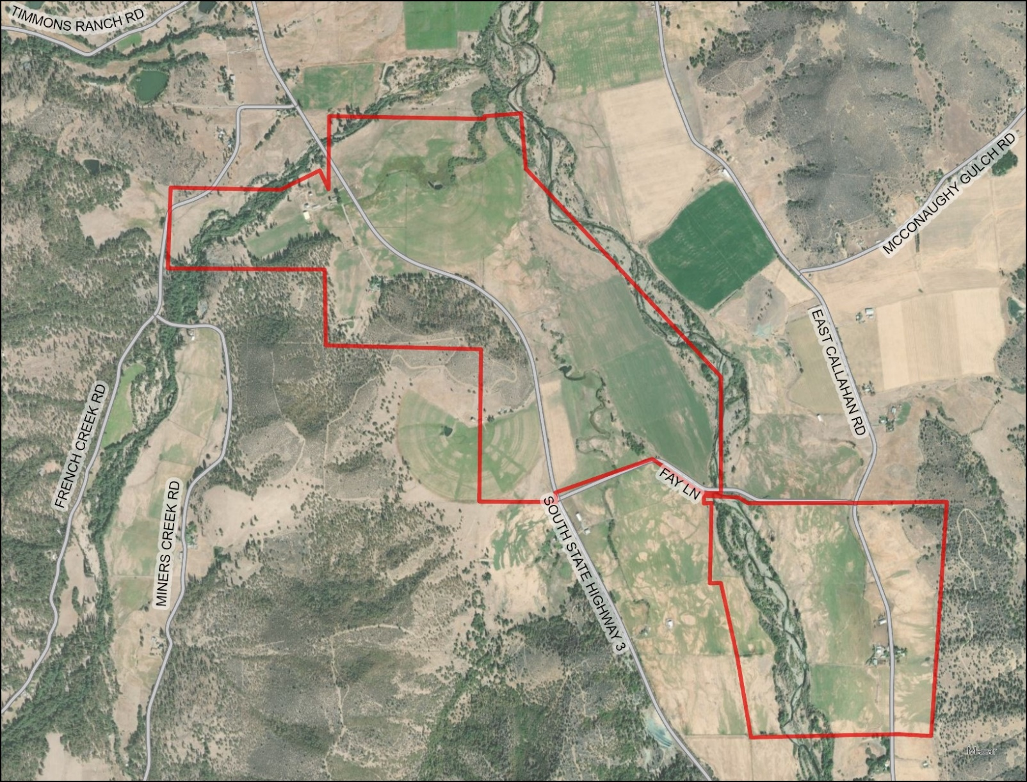   
Figure 1: Subject Parcels

## Comments

Agency CommentsEnvironmental Health commented specifically on the Boundary Line Adjustment proposal.   
No agency had any objections to the project as proposed.

Public Comments  
Notice of the project was published and posted as required prior to the Board of Supervisors meeting and no public comment was received as of the preparation of this staff report.

## Recommended Action

Should the Board of Supervisors concur with staff’s analysis, staff recommends that the Board of Supervisors find that the proposed modifications to the Williamson Act contract and Agricultural Preserve and issuance of a Notice of Non-Renewal are exempt from CEQA and approve said modifications.

A draft motion to this effect is provided below.

## Recommended Motions

I move to take the following actions:

1. Determine the project exempt from CEQA in accordance with Section 15317, Open Space Easements or Contracts; and
2. Adopt the attached resolution approving amendment to the existing Agricultural Preserve and establishment of a new preserve; and
3. Adopt the attached resolution approving the rescission and reentry of the applicable Williamson Act contracts; and
4. Adopt the attached resolution directing staff to process the Notice of Non-Renewal for the 1-acre and 3.2-acre substandard parcels, with any changes directed by the Board.

## Exhibits to the Staff Report

1. Draft Resolution amending the existing Agricultural Preserve and establishing a new preserve
2. Draft Resolution Approving the Rescission of the subject property from the existing contracts and Reentry into new Williamson Act Contracts
3. Exhibit A within Draft Resolution: Williamson Act Contract Barnes – Draft
4. Exhibit B within Draft Resolution: Williamson Act Contract Johnson - Draft
5. Draft Resolution directing staff to issue a Notice of Non-Renewal for portion of Contract– Johnson
   * + 1. Exhibit A within Draft Resolution: Notice of Non-Renewal
6. Agricultural Preserve Administrator Staff Report with Recommendation